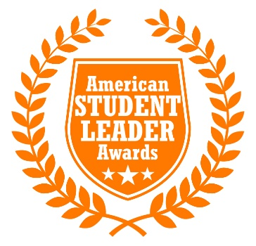
2023
American Student Government Advisor
of the Year
This is a leadership and service award.

Eligibility Requirements
Applicants will be judged on specific examples of service and leadership in advising their Student Governments. Individual judges may assign different weight to each of the criteria.
Applicants must be currently employed at a community college, private university, state university, or accredited vocational, technical, or business school located in the United States of America.
The school and individual campus at which you are employed also must be located physically in the United States.
Applicants do not have to be nominated by their colleges to be eligible, but colleges/universities may nominate Advisors.
Advisors are permitted and encouraged to apply on their own.
There is no limit to the number of applicants who can enter from a particular institution.
Applicants must agree, if selected as one of the three honorees in each category (public institutions, private institutions, community/technical colleges), to attend the 2023 Spring Student Government Summit.
The following individuals are not eligible: current employees or relatives of employees of College Student of the Year, Inc., the American Student Government Association, or any co-sponsor.
Three finalists will be chosen in each category.
Travel and hotel expenses to attend the awards ceremony are the responsibility of each applicant, although some or all expenses may be covered by the applicant’s institution and/or by sponsors.
Honorees agree to allow College Student of the Year, Inc. and ASGA to use their names, applications, voices, and/or likenesses in subsequent articles and/or public relations materials.
Income taxes on all prizes awarded are the sole responsibility of the recipients.
The judges reserve the right to exclude potential or current honorees whose applications prove to be false or misleading, before or after the judging process.
How To Enter
1. Answer the four essay questions in the nomination form at the Awards web site. Specifically state what difference you have made, not just what you have done.
2. Upload a typed resume detailing your professional experience advising Student Governments.
3. Upload exactly two letters of recommendation, which confirm your eligibility and suitability for the award. The letters must addressed to the American Student Leader of the Year Awards. The letters may be from civic leaders, faculty or administration members, student leaders, administrators, or others. All letters must include the writer’s return mailing address, telephone number, and e-mail address.
4. Upload a current color "head-and-shoulders" portrait photo of yourself which may be used for publication.
8. Optional—Upload additional information such as videos, newspaper clippings, letters, and/or copies of awards and certificates that highlight your achievements as an advisor.
Applications must be submitted using the official forms.
Applications must received by midnight Pacific Standard Time on February 1, 2023.
All instructions must be followed exactly or the application will not be considered.
All materials become property of College Student of the Year, Inc. and may be used for publication.
Please see www.studentleaderawards.org for more information.

